**Automated Access Control System (AACS)**

**Photo Upload System Guide**

**Version**: V1.4 2024

**Introduction**

To continue keeping Scottish Government and its estate safe, secure, and resilient, a new access control system will be rolled out in the coming months.

The current Scottish Government automated access control system is being updated with a more up to date and secure system, and we will be adopting the GovPass system, the same system which the Government Property Agency is rolling out across the UK Government estate.

The system will not change much from how it is currently. Staff will still present their pass to a reader, and in some cases use a PIN number. To implement this new system, Scottish Government staff will be required to update their current pass, including taking a new photo. If you are unable to take a photo yourself of have someone take one for you can contact the us at [passrefresh@gov.scot](mailto:passrefresh@gov.scot%20)  and we’ll make alternative arrangements.

This how to guide will take you through the process step by step, including the best way to take your photo.

**Step 1**

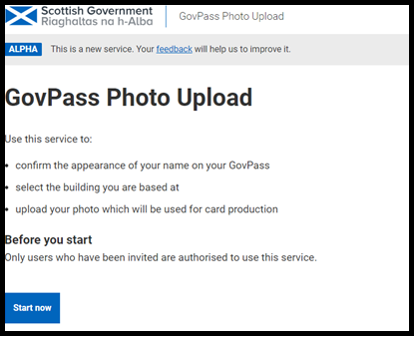

You will receive a link from govpass.systems and you will be taken to the GovPass photo upload web page. Click “Start now” to continue.

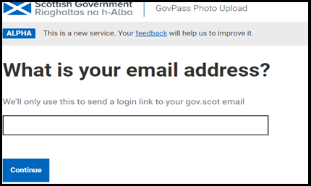**Step 2**

This step will allow you to enter you Scottish Government email address which will be matched with the invite you received to bring up the correct record details.

Click “Continue” to move on.

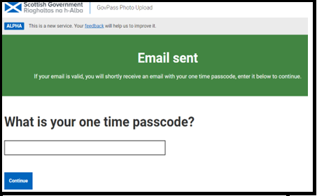**Step 3**

At this step, an authentication code will be sent to the email address provided. This may take time so please allow up to 3 to 5 minutes to receive the code.

Once enter, click continue to move on.

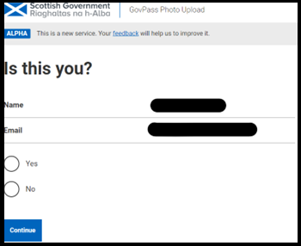**Step 4**

This screen will allow you to confirm your name, as it will appear on your new pass. Your name and email address will appear. If this is you, select yes and continue. If not, select no and continue. If your details are incorrect you will need to email [passrefresh@gov.scot](mailto:passrefresh@gov.scot).

We will endevour to reply as soon as possible but pleasse note this mail box is only monitored durying normal office hours

**Step 5**

The next screen allows you to confirm your details.

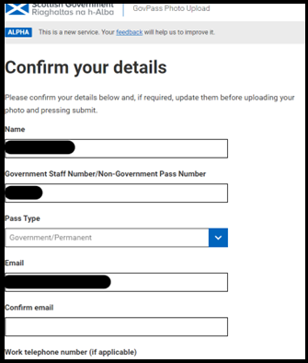There will be some details that are pre-populated from the system invite. Please ensure these are correct and proceed to complete the rest of the fields. If you have already been in the system and returned, some items may already be pre-populated.

Key points to note: -

*Pass Type*

You have the option of Government/Permanent

or Non-Government/Contactor/ Time-Dated.

Please select the correct option

If you select Non-Government/Contactor/Time-Dated

please use your pass number.

*Staff Number*

Please just enter the number not the leading letter

Work Telephone Number, leave blank If you do not

have one.

Directorate This may be pre-populated, or you may

have to select it.

**Step 6**

This step is where you will upload your photo.

Your new pass photo will be just like a passport photo, and we suggest you have this ready before starting the process, but if you’d like additional guidance, please see the UK passport guidance image.

[UK Passport Image Guidance](https://assets.publishing.service.gov.uk/media/60a384e6d3bf7f0a00ab1b88/Adult_Photo_guidance_HMPO-v2.jpeg)

The key points are: -

* You can use the front facing camera on your mobile phone or ask someone to help you.
* Find a well-lit area with a plain single colour background.
* Ensure you are facing forward and looking straight into the camera, and that your head and shoulders are clearly visible with space around you.
* Try to ensure there are no shadows or objects behind you.
* Keep a neutral expression with your mouth closed and ensure that your eyes are open, and your hair is not covering your face.
* If you wear glasses, they cannot be sunglasses or tinted glasses, and you must make sure your eyes are not covered by the frames or any glare, reflection, or shadow.
* Please ensure that your full head is showing, without anything on it, unless you wear a head covering for religious or medical reasons. Dual passes are available if required.
* Ensure that the photo is clear and in focus, is in colour and does not have a filter applied or the image may be rejected.

If you require to check the sizing of your image, both Apple and Android phones contain an on-screen button like the image. This will provide you with the image size information.

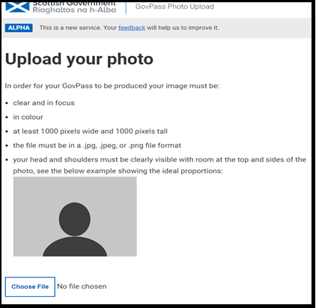Should you require to re-size your image, please refer to the manufacturers guide for your phone.

Once you upload a photo and click continue, the system will either advise the photo is not suitable and ask you to upload another or it will provide a preview of the image you have uploaded and ask you to Submit or Reupload.

Please allow a few seconds for the picture to upload and be assessed.

**Step 7**

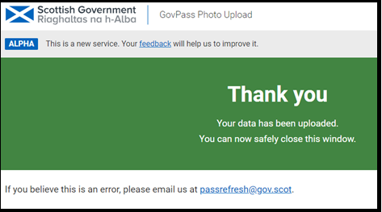Your image is now submitted, and your pass will be added to the batch queue for printing. Please keep an eye on communication messages around pass collection.

Security and Business Continuity Colleagues can be contacted by emailing [passrefresh@gov.scot](mailto:passrefresh@gov.scot%20)