**LIFE CYCLE COSTING**

examples FOR SCOTTISH PUBLIC BODIES

Produced by Barbara Morton and Philip Duddell, Sustainable Procurement Limited:

[Barbara@sustainableprocurement.eu.com](mailto:Barbara@sustainableprocurement.eu.com)

[Philip@sustainableprocurement.eu.com](mailto:Philip@sustainableprocurement.eu.com)

[www.sustainableprocurement.eu.com](http://www.sustainableprocurement.eu.com)

Contents

LIFE CYCLE COSTING 3

What does it mean? 3

Why consider life cycle costs 3

When to consider 3

KEEPING IT SIMPLE 4

EXAMPLES FOR SERVICE CONTRACTS 5

Professional Services - Legal Services contract or framework 6

Hard FM Contract or Framework 8

Procurement of Furniture, with installation, repair, refurbishment, end of life management services 10

National Records of Scotland (NRS) – Scotland’s Census 2021 Online Collection 12

APPENDIX 1: ‘DECISION TREE’ 13

APPENDIX 2: LIST OF POSSIBLE COSTS TO SELECT FROM – OTHERS MAY APPLY 14

# LIFE CYCLE COSTING

What does it mean?

Consider all **relevant** costs that relate to a contract or framework:

1. Those distinct costs that you will need to determine from bidders for contracts or frameworks.
2. You should also consider any costs that may be incurred by the Contracting Authority – these may relate to internal costs such as energy, waste disposal, infrastructure, training or others.

The key is being able to determine the scope of costs that are relevant – in some cases this may be very simple; in others there may be a range of distinct costs that need to be determined.

You need to consider relevant costs only, according to the scope of the contract or framework.

While Life Cycle Costing includes potential consideration of costs relating to **Acquisition, Use, Maintenance and End of Life,** as Regulation 68[1] states it may cover ‘part or all’ of these costs.

Costs *may* also include ‘Environmental Externalities’, provided monetary value can be determined and verified. These are any costs that may arise relating to energy and water consumption, mitigation of climate change, prevention of pollution, clean up or related taxes, such as carbon taxes1.

You may already be adequately considering all relevant costs relating to a contract or framework but may not always label it ‘Life Cycle Costing analysis‘.

Data must be objective, verifiable, accessible and be readily available.

Some ‘end of life costs’ may refer to a resale value as well as disposal or removal costs.

The scope and method to be used for assessing all relevant costs must be identified and published.

Why consider life cycle costs

* It is set out in Procurement Regulations and Statutory Guidance as set out above.
* You need to determine all relevant costs that suppliers will impose during the Life Cycle of the Works, Goods or Service so that you can evaluate competing options and determine best value for money.
* You need to determine all other costs that may fall upon the Contracting Authority so that there is greater awareness of total costs and transparency of future costs.
* Contracting Authorities may not buy on price alone. A contracting authority must identify the most economically advantageous tender on the basis of the **best price-quality ratio**, which must be assessed on the basis of criteria linked to the subject-matter of the public contract in question and must include the price or cost, using a cost effectiveness approach. A cost-effectiveness approach may include Life-Cycle Costing in accordance with regulation 68 (Life-Cycle Costing)[2].

When to consider

All relevant costs should be considered:

* At strategy planning stage – to consider potential options and informs the business case and budget.
* At the Design phase - to determine alternative business models/options.
* At tender development stage – to determine the cost model and method for ITT evaluation.
* At the Bid evaluation stage – to compare competing bids for products and services.

Key stakeholders involved may include Budget Holders, Finance Department, Heads of Finance, Heads of Service, End Users, Internal Customers, Procurement, Facilities Management and others, according to the scope of the contract or framework.

Consideration of Life Cycle Costs requires consideration of all costs associated with the procurement and all other costs the Contracting Authority may incur – this requires coordination between budget holders.

# KEEPING IT SIMPLE

Consideration of Life Cycle Costs does not need to be complex.

The following are key steps to help you consider Life Cycle Costs in a relevant and proportionate manner:

**Develop Strategy**

Consider what the relevant Life Cycle of the potential project is. Does it relate to the lifetime of the contract or lifetime of product/equipment or building?

**Options appraisal**

Have all relevant costs been considered when determining chosen option?

**Contract/ Framework Development**

Have all relevant costs been considered when determining the cost model and method for ITT evaluation?

Cost model and methodology for determining Life Cycle Costs, including externalities where relevant, published.

Evaluate bids using cost model, reflecting agreed scope of Life Cycle Costs.

Do all relevant Stakeholders consider all relevant costs*e.g.

* Acquisition, Use, Maintenance and End of Life?
* Market costs *and* those incurred internally by Contracting Authority?
* Any Environmental externalities?

Scope of costs agreed within Budget, Options

Yes

No

Methodology for determining costs agreed

**ITT evaluation**

*Relevant costs depend on the Scope of the Contract or Framework.

**Products** - In the case of the procurement of a Product the only market cost that may be relevant is the purchase price. If, however, there is a potential for energy or water to be consumed by that product and/or it may result in waste being generated, those (estimated) costs may need to be considered. These would be internal to the Contracting Authority (assuming that the supplier has no responsibility for them under the contract) but may form part of the evaluation of best value for money.

Other cost considerations for Products may include lease or rental, costs of installing a product (in the case of equipment), licenses, insurance, upgrading, servicing and others according to the product.

**Works** – Works contracts can vary from simple refurbishment to major infrastructure. A full Life Cycle Cost (within construction the term used is Whole Life Cost) will usually be required. SFT has developed a Whole Life Cost tool

**Services** – Services can vary considerably in their scope and subject matter. Life Cycle stages that relate to services may include ‘Set-up of service’, ‘Service delivery’ and ‘Service closure/transfer’. A service contract may relate to the provision of a product or commodity (e.g. workwear) with an associated service (e.g. repair).

Costs that may be relevant include a service charge that covers all requirements. Separate costs may however in some cases relate to training, servicing, maintenance and repair and others, according to the nature of the contract or framework.

A Decision Tree is included in Appendix 1 that is designed to help you to consider what the scope of relevant costs is. It is a prompt to encourage you to consider the scope of costs and does not necessarily include all those that may be relevant. This is followed by a list of possible costs, including those that the market will impose as well as those internal (non-contract) costs that may fall on the Contracting Authority, to be selected from. It should be stressed this is not an exhaustive list and others may apply. In some cases, just a few costs may apply; in others a range of separate costs may be relevant.

# EXAMPLES FOR SERVICE CONTRACTS

There are a number of examples of Whole Life Costs for Construction projects. However, there exist relatively few examples for Services contracts.

The following are examples that are designed to ‘de-mystify’ Life Cycle Cost consideration.

|  |  |
| --- | --- |
| Professional Services - Legal Services contract or framework | |
| **Scope of contract/ framework:** | The provision of:   * Contract, commercial and corporate law * Litigation, reparation, employment and inquiries * Property and related matters   A 4-year contract/framework. |
| **Background:** | While this example covers a range of legal services in practice they are likely to relate to:   * Process driven work – where a fixed fee is usually charged * Negotiated work – where hourly rates are likely to be applied   As part of the tender you will be seeking evidence of who will be delivering the work and their position (e.g. Partner, Senior Lawyer, Lawyer, Paralegal). Their hourly rates will vary.  Legal companies may provide a rebate if services are retained after an initial period.  They may also apply discounts for bulk instructions.  Fees may be subject to indexation (although not usually).  Additional services such as storage and access to electronic data and records and the provision of secondees to the client may incur an additional charge or be included as an ‘added value’ without charge. |
| **Scope of Life Cycle Costs:** | Given the above the scope of costs that are relevant includes:   * **Scope of costs:** * Fixed fees – for specific processes (e.g. lease renewal, contract renewal, training for public sector on specific legal requirements and others) * Hourly fees – for specific negotiated work (e.g. litigation, employment disputes, bespoke training) * Ad-hoc fees (if relevant) for any ‘additional services’ * **Cost model:** Given the sometimes ad-hoc nature of any professional services contract, in order to compare bids bidders may be asked to provide costs for a set number of process driven projects and negotiated work, with relevant hourly rates, any discounts, rebates and indexation applied during a set period (either the full term of the Framework or, such as, after 2 years). * **End of life:** It may also be necessary to get clarification if any ‘transfer costs’ apply, in the event of changing the provider at the end of the contract/ framework (e.g. release of deeds/documents to new provider). |
| **Lessons:** | In the case of Legal Services Life Cycle Costs will relate solely to the service being provided.  It is not necessary to obtain details of other costs, including environmental externalities, as the service is being undertaken primarily at their site and they will have responsibility for all of their utility, waste, transport and materials costs (you are likely to require evidence of how the supplier will manage such environmental impacts as part of a ‘Sustainability - Quality’ assessment but you don’t need cost details).  This may be similar to other professional service contracts – but ensure costs relate directly to the scope of the contract or framework. |

|  |  |
| --- | --- |
| Hard FM Contract or Framework | |
| **Scope of contract/ framework:** | The provision of:  Mechanical, fire and electrical services for a public-sector estate.  A 4-year contract/framework. |
| **Background:** | Hard FM services can vary in scope. For the purposes of this example we are assuming that the services comprise installation, alterations, reactive and planned periodic maintenance for:   * Plumbing * Heating, ventilation and air conditioning * Commercial boiler * WC, washroom and shower rooms * Electrical Systems * Electrical re-wire and lighting schemes * Emergency Lighting and Fire Alarm systems * Intruder Alarm, Access Control and CCTV Systems * Periodic Electrical Inspections * Portable Appliance Testing   It is recognised that a number of cost models exist for FM Services. These include ‘Cost Plus, ‘Target Cost’, ‘Guaranteed Maximum Price’, ‘Fixed Price’ and ‘Partial or nil subsidy’. |
| **Scope of Life Cycle Costs:** | Given the above the scope of costs that are relevant includes:   * **Scope of Market costs:** * Set up costs – this may include TUPE costs. TUPE liabilities may be based on a “TUPE premium” per individual which will value the variance from standard rates and apply to the annual service cost. * Annual service charge – the FM Provider will charge the service fee for services provided, based on the chosen cost model. Administration and helpdesk costs may be separated from others. * Resource efficiency - being responsible for the efficiency of heating, cooling, lighting and other energy systems the Provider may be incentivised to deliver resource efficiency savings, depending on the chosen model. This may include the Renewable Heat Incentive (RHI) which pays quarterly payments for eligible installations for up to 20 years, so the model needs to reflect potential receipts as well as payments. * End of life costs – waste will be generated through service delivery and the Provider may be required to take this away for appropriate management, in accordance with the waste hierarchy, or place it in the client’s skips. This will be addressed through requirements to manage waste so as to minimise it, maximise re-use and recycling and it is not relevant to obtain costs for this. * **Scope of Internal costs:** * Mobilisation costs for such a contract can be significant. |
| **Lessons:** | A Hard FM contract inevitably requires consideration of a range of underlying costs relating to M&E assets and costs, utilities relating to operation of assets, cyclical inspections, repairs and replacement of minor components and replacement of major systems and components. The relevant cost model will determine how this is managed, including potentially by reference to BS8544:2013, while seeking to minimize market related risks.  There is considerable experience of applying cost models to such contracts within the public sector. |

|  |  |
| --- | --- |
| Procurement of Furniture, with installation, repair, refurbishment, end of life management services | |
| **Scope of contract/ framework:** | The provision of:  Office furniture as a commodity. This may be new or refurbished/ remanufactured furniture.  The provider is responsible for the supply, installation, tracking, repair, refurbishment and end of life management of the furniture.  A 4-year contract/framework. |
| **Background:** | The contract requires the contractor to supply new or refurbished furniture, to manage these and legacy furniture; repairing, refurbishing or otherwise recycling redundant furniture. At all times it should maintain a register of furniture.  While the assumption is that the contracting authority would be buying and owning the furniture and associated services (option A) it may consider an alternative furniture managed service, where the supplier retains ownership of the furniture and provides the required functionality (this may be through a hire or rental arrangement or a managed service - option B). |
| **Scope of Life Cycle Costs:** | The scope of costs will depend on which procurement option is selected (A or B above). The following considers relevant costs. These costs may be considered at the strategy stage to consider relevant budget and options.   1. **OPTION A: Scope of market costs**  * Cost of new furniture per item, based on agreed list of required core office furniture and non-core furniture. These costs include supply and installation. * Asset tracking service including RFID tagging – covers new and legacy furniture at price per asset. * Repair and refurbishment service for new and legacy furniture; this will either be a fixed price per asset and/or included within the price of each new asset. * If not capable of repair/ refurbishment the, otherwise redundant, furniture will be re-used where possible. How this may be done will be a concern within the tender and responses will be evaluated accordingly. This re-use may be in conjunction with a third sector/ supported business partner for example and/or there may be a resale value in some cases. Failing that the assets should be recycled in accordance with legal requirements. This may be a separate charge (e.g. in the case of legacy furniture) and/or included within the price per asset.   This contract includes the ‘waste management service’ to uplift furniture and allocate for re-use or recycling. If the contract did not include this, but there existed a separate waste management contract, impacts on this contract costs, arising from the design, scale and use of furniture should be considered (not relevant for new furniture in the case of option B).   * Additional ad-hoc costs may need to be considered, such as redeployment of furniture to an alternative site(s) and/or space design and utilisation services, ergonomic workplace assessments. This may be included within the cost model – considering costs based on an assumed number of new assets and legacy assets and repair/refurbishment requirements.  1. **OPTION B: Scope of market costs**  * This may incur a hire or rental fee. Given the legacy furniture a separate asset tracking, repair and refurbishment fee and ‘waste management’ fee may be applied to these. * A Managed Furniture service will incur a service fee which would cover all supply, installation, repair, refurbishment, re-use and recycling, moving, space planning and ergonomic assessment services.   In addition to the alternative costs there will be other considerations not addressed here in detail – such as capital and revenue budgeting, availability of market options, market related risks and end of contract risks – in the case of hire, rental or Managed Service options as the furniture ownership remains with the supplier a key consideration will be how to ensure continuing furniture availability if the supplier changes. |
| **Lessons:** | While a supplier may charge a single price per unit of core and non-core furniture it is important to understand the scope of underlying relevant costs. These may as an alternative be charged separately and an understanding of chargeable costs and any complementary services is important to ensure a grasp of overall Life Cycle Costs.  ‘End of life’ costs are a key element of a contract such as this. Even if a furniture contract merely involves the procurement of a commodity with no associated services, awareness of the impact on related costs, such as ‘waste management’ of furniture, for example managed by the contracting authority’s FM team, is essential. These costs will of course be influenced by the durability, longevity and use of the furniture, as well as how otherwise redundant furniture is dealt with. |

The following is an example of an awarded contract, based on the procurement of Census 2021 services. The contract was awarded in January 2018.

|  |  |
| --- | --- |
| National Records of Scotland (NRS) – Scotland’s Census 2021 Online Collection | |
| **Scope of contract/ framework:** | 2 contracts were issued by NRS - ‘Online Collection’ and ‘Data Analysis’.  The Online Collection contract involved online data collection and storage through the web portal and then eventual secure decommissioning of the online instrument and data.  The contract is split into three phases:   1. Discovery stage – approximately a year from Jan 2018 2. Rehearsal stage in 2019 3. Census 2021 |
| **Background:** | The contractor is required to liaise with the contractor on the Data Analysis contract to ensure appropriate integration. |
| **Scope of Life Cycle Costs:** | **Scope of market costs**  The contract requires identification of costs for each of the three stages.  However, within each of these stages the costs covering the provision of the web portal, Census data collection and eventual destruction are not separately costed but included in overall charges for each stage.  Bidders were instructed to cost the contract on this basis. |
| **Lessons:** | This is an example of a contract where there are a number of relevant costs. These were not costed separately but considered by bidders in their overall commercial offering.  There may be situations in other contracts where separate costs may be required – for example if delivery of the overall contract is subject to a staged process with a gateway review at each stage to determine whether it should proceed further or to ensure transparency in overall costs breakdown. |

# APPENDIX 1: ‘DECISION TREE’

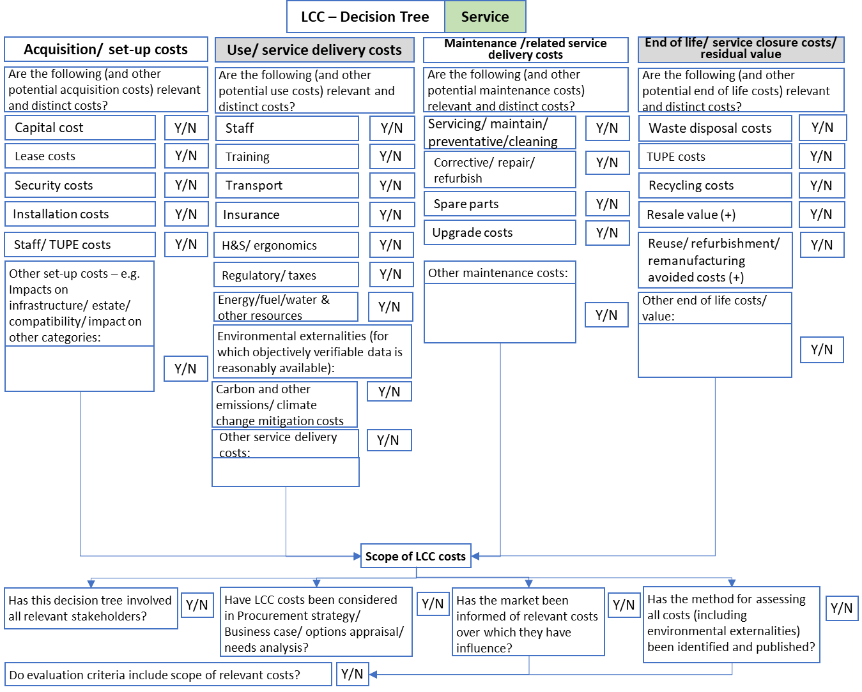

# APPENDIX 2: LIST OF POSSIBLE COSTS TO SELECT FROM – OTHERS MAY APPLY

|  |  |  |  |
| --- | --- | --- | --- |
| **LIFE CYCLE STAGE** | **Are the following potential costs relevant and distinct?** | **Yes or N/A** | **Source? Internal or Market?** |
| **Acquisition /set-up costs** | Capital cost/ initial purchase price |  |  |
| **Acquisition /set-up costs** | Lease costs |  |  |
| **Acquisition /set-up costs** | Hire/rent costs |  |  |
| **Acquisition /set-up costs** | Installation costs |  |  |
| **Acquisition /set-up costs** | Research costs |  |  |
| **Acquisition /set-up costs** | Staff/ TUPE costs |  |  |
| **Acquisition /set-up costs** | Other set up costs– e.g. Impacts on infrastructure/ estate/ compatibility/ other categories: |  |  |
| **Acquisition /set-up costs** | Other set up costs– e.g. Impacts on infrastructure/ estate/ compatibility/ other categories: |  |  |
| **Acquisition /set-up costs** | Other set up costs– e.g. Impacts on infrastructure/ estate/ compatibility/ other categories: |  |  |
| **Use /service delivery costs** | Staff training |  |  |
| **Use /service delivery costs** | Licences |  |  |
| **Use /service delivery costs** | Consumables |  |  |
| **Use /service delivery costs** | Insurance |  |  |
| **Use /service delivery costs** | Stock Management |  |  |
| **Use /service delivery costs** | H&S/PPE/ ergonomics |  |  |
| **Use /service delivery costs** | Regulatory/ taxes |  |  |
| **Use /service delivery costs** | Supplies price rises |  |  |
| **Use /service delivery costs** | Energy/fuel/water & other resources |  |  |
| **Use /service delivery costs** | ***Environmental externalities (for which objectively verifiable data is reasonably available):*** |  |  |
| **Use /service delivery costs** | Carbon & other emissions/ climate change mitigation costs/ RHI, FiT Tariffs (insert -ve) |  |  |
| **Use /service delivery costs** | Insert detail of other use cost |  |  |
| **Use /service delivery costs** | Insert detail of other use cost |  |  |
| **Use /service delivery costs** | Insert detail of other use cost |  |  |
| **Maintenance /related service costs** | Servicing/ maintenance/ preventative/ cleaning |  |  |
| **Maintenance /related service costs** | Corrective/ repair/ refurbish |  |  |
| **Maintenance /related service costs** | Spare parts |  |  |
| **Maintenance /related service costs** | Upgrade costs |  |  |
| **Maintenance /related service costs** | Insert detail of other maintenance cost |  |  |
| **Maintenance /related service costs** | Insert detail of other maintenance cost |  |  |
| **Maintenance /related service costs** | Insert detail of other maintenance cost |  |  |
| **End of life /service closure / value** | Disposal costs |  |  |
| **End of life /service closure / value** | Consumables disposal costs |  |  |
| **End of life /service closure / value** | Recycling costs |  |  |
| **End of life /service closure / value** | Resale future value (insert -ve) |  |  |
| **End of life /service closure / value** | Reuse/ remanufacturing, refurbishment avoided costs (insert -ve) |  |  |
| **End of life /service closure / value** | Water effluent treatment costs |  |  |
| **End of life /service closure / value** | Transfer/ TUPE costs |  |  |
| **End of life /service closure / value** | Insert detail of other end of life cost/ value |  |  |
| **End of life /service closure / value** | Insert detail of other end of life cost/ value |  |  |
| **End of life /service closure / value** | Insert detail of other end of life cost/ value |  |  |

1. Public Contracts (Scotland) Regulations 2015 Regulations 67 & 68. http://www.legislation.gov.uk/ssi/2015/446/pdfs/ssi_20150446_en.pdf
2. Public Contracts (Scotland) Regulations 2015 Regulations 67.