Examples of Payment Performance Evidence

1. UK Government Published Payment Practice Reports

2. Accounts Payable Report

3. Payment Performance Statement Signed by External Auditor

4. Credit Score / Credit Report Provider

5. Accounts Payable Ratio

**1. UK Government Published Payment Practice Reports**

Link: [Search for published payment practice reports (check-payment-practices.service.gov.uk)](https://check-payment-practices.service.gov.uk/search?q=)

* Free, accessible, up to date
* Suppliers meeting specific threshold requirements **must** publish to this site however suppliers can publish voluntarily.

*Example of payment practice report extract:*

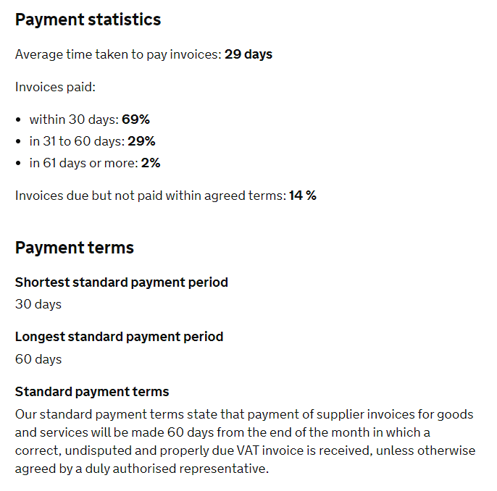

**2. Accounts Payable Report**

Below is an example of a SG AP report detailing payment performance for a specific time period:

|  |  |  |  |  |  |  |  |  |
| --- | --- | --- | --- | --- | --- | --- | --- | --- |
| Directorate General | Number of Invoices | Total Paid in 10 days | Average number of days between “stamped date” and “in bank day” | Percentage Paid in 10 days | Average number of days between “Supplier Invoice Date” and “Stamped Date” | Average number of days between “Stamped Date” and “Entered Date” | Average number of days between “Entered Date” and “Validated Date” | Average number of days between ”Validated Date” and “In Bank Date” |
| A | 788 | 768 | 4 | 97 | 6 | 1 | 1 | 2 |
| B | 100 | 94 | 5 | 94 | 5 | 1 | 2 | 2 |
| C | 1,361 | 1,330 | 5 | 98 | 9 | 2 | 1 | 2 |
| D | 1,018 | 947 | 6 | 93 | 9 | 1 | 3 | 2 |
| E | 692 | 682 | 4 | 99 | 6 | 1 | 1 | 2 |
| F | 325 | 296 | 6 | 91 | 5 | 1 | 3 | 2 |
| G | 16 | 16 | 4 | 100 | 33 | 1 | 1 | 2 |

* Any AP report detailing the “invoice receipt date” and “In Bank Date/Invoice Paid Date” could be used to evidence payment performance
* Accessible, easy to use & up to date

**3. Payment Performance Statement Signed by External Auditor**

A statement on payment performance signed by an external auditor could be used as evidence. The statement must contain the declaration that “the supplier pays X% of invoices in line with their X day payment terms”.

**4. Credit Score / Credit Report Provider**

A number of suppliers provide a similar service such as Equifax, Experien & Dun & Bradstreet. The example below is an extract from Creditsafe. Points to note:

* A calculation may be needed to dermine the average payment performace percentage
* The data is not 100% accurate as it is based on payment data which is shared by the credit report provider partners/suppliers
* This is a paid service

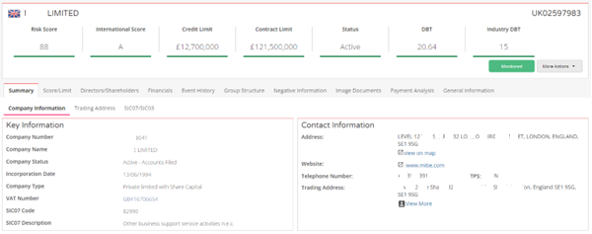

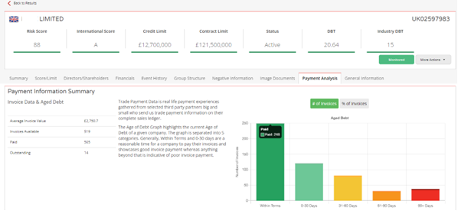

**5. Accounts Payable Ratio**

* Possibly use alongside other methods above as verification
* May be out of date depending on when the accounts were filed and any extenuating circumstances at time of filing
* Only a snapshot value for the time of the filing
* Payables turnover ratio=

(Cost of Sales (Supplier Purchases) / Accounts Payable (Total Liabilities))

* Accounts Payable Turnover in Days=

(365/Payable turnover ratio)

* Example: Companies House reports filed for Mitie Ltd which are freely available. Using their filed accounts up to 31 March 2021:

Payables turnover ratio = Cost of Sales (533,250)/Total Liabilities (119,184) = 4.47

Accounts Payable Turnover = 365/4.47 = 81 days